Introductory Paragraph
These days in the world, there are a lot of natural disasters going on such as earthquakes, floods, Tsunamis, Volcano eruptions, and etc. As time goes by a lot of natural disasters are happening and they are affecting us more and more. Because there are a lot of natural disasters happening around us, there are NGO’s and organizations which help people when a disaster strikes. If there is a disaster a number of shelters are damaged and people are left to nowhere to go. That is why some NGO’s provide the citizens with an emergency shelter which is a temporary home for people who have lost their homes because of the disaster. For Design Technology class we have to make a model of the Emergency shelter that we are going to make for a natural disaster. As everyone knows, there was a deadly flood in China a while ago and China is getting hit by floods recently as well. That is why I am working on emergency shelters for floods in China.

Brainstorming of Potential Problems to be solved
While I am building the real model of the emergency shelter some problems might be costs and materials. My shelter is going to be in China and china has a lot of people which requires me to make lots of emergency shelters for the population. The size should be big so that it could house about 5-10 people per emergency shelter. The location can be a problem as well. There are a lot of people living in China and in order to make a society there needs to be a lot of people in one area. With the building and houses all destroyed the trash will block the people from living in one area together where they will be safe. This is one problem that I am worried about. If I am willing to build a lot of emergency shelters, which I am, I am going to need a lot of money. If I do have enough money and raise the cost of the emergency shelter governments might not be able to buy my shelter. That is why cost is the problem, I have to have enough money and it can’t be too costly for governments. Lastly, Materials might be a problem. My natural disaster that I am going to build emergency shelter for is floods in China and there needs to be enough material for all of the people in China. As everyone knows China has the most people in the world. Even if it was a certain part of China, there would be a lot more people than other countries. Where am I going to get all those materials that I need for my emergency shelter? These are my major problems that have to be solved in order for me to make a successful emergency shelter. To sum up some of the problems of building my emergency shelter is:
- Location
- Money
- Materials

Problem Definition + Choice of Client and Audience
My emergency shelter could benefit people and the society in a lot of ways. My idea of having emergency shelters in China is worthwhile because it can help those who have lost their homes in the flood. It could also help families reunite because if they hear that there is an emergency shelter and go to that area and see their families and can live together in the emergency shelter. It could also be worthwhile because if another flood hits China latter they could reuse the emergency shelter again which saves money for the government. Society will benefit from it because there would be less people in the streets and more people who know what is going on and people who know what they can do to make this situation pass without any damages. The society can also plan what they can do to save the area and rebuild to take action. Just having an emergency shelter can help the society and people in a lot of ways.

Brainstorming of Possible Solutions / Products
As I mentioned before the main problems that I have for building my emergency shelter is the location, cost, and materials. The problems for Locations where that the trash from the broken down buildings would not allow the people to live in one location together the solution to this can be:
- First moving the trash to one area or cleaning it so that the people can make a society together.
- They could make smaller groups of people and meet together once a week for talking about the society.

The problem for costs is that I have to use a lot of money and if I raise the money the government is not going to be able to buy my emergency shelter. I think some solutions for cost is:
- I am going to use materials that doesn’t cost as much but does not make any problems for the people to live in.
- I am going to lower the cost because the government can buy more and that could benefit the people more.
Another problem that I had was the materials that I was going to use for all those people that need help. Some solutions can be:
- Use recycled material for the emergency shelter.
- But a lot of people in one emergency shelter.
- Don’t use wood and use things that it is alright to use a lot of.
- Ask environmental NGO’s to support our emergency shelter team so they can provide us with material that will help the environment as well as help the people who need an emergency shelter.

Client Interview
Q: What material should I use to make my emergency shelter?
A: You should use some metal for sturdiness.
Q: What size should the emergency shelter be?
A: The room has to be big enough to contain 5-10 people in each emergency shelter.

Q: What sort of lights should I use for the emergency shelter?
A: You should use natural sunlight.

Q: How many lights should there be?
A: The lights should be all around because it is natural sunlight.
Q: How many people should be in each emergency shelter?
A: 5-10 people
Q: Is it better for the emergency shelter to be foldable or should it have wheels for transportation.
A: It needs to be foldable.
Q: What shape should the emergency shelter be?
A: It should be a unique shape.
Q: What kind of materials do the people need to survive in the emergency shelter?
A: Sunlight.
Q: How much should the emergency shelter cost?
A: 100 TL
Q: How should the emergency shelter look like overall?
A: It should look warm and cozy.
Q: How many emergency shelters should there be?
A: 1,050 emergency shelters because there are a lot of people in china.
Choice of product
Some reasons that my emergency shelter is the best for the flood is because:
- It is especially built for floods and will stop further damage to the people.
- It costs less because it is made out of material that is strong but is cheap.
- The emergency shelter will fill in a lot of people but will provide enough space for all of the people who need a home.
- The emergency shelter will be comfortable and not hard and cramped so that the people can be relaxed while they are living in the emergency shelter.
These reasons are some of the reasons why my emergency shelter is the best choice that people can make.

Case Study

These are some of the emergency shelters for floods that caught my eye:

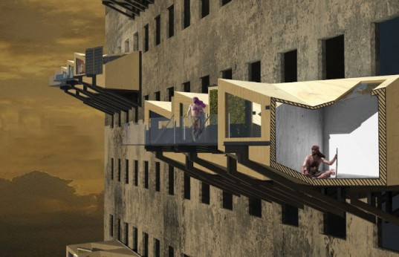
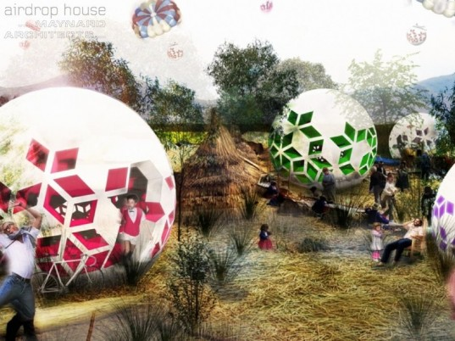

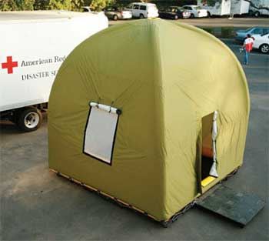

- The first model is my favorite because it can be used in a lot of ways. There are steps where this can be used:
- First the airdrop housed is transported to a flooded area by a military weapon delivery infrastructure to quickly deliver the aid and the airdrop house.
- The shelter is dropped from the military weapon delivery infrastructure by a bomber.
- The house is weighed and designed so that it lands in the correct upright position that it is supposed to be in. This house is about 1 meter in diameter. The shelter is made out of a sponge like material so when it hits ground it starts sucking up the water around it.
- While the house keeps on sucking up water the shelters volume increases. When it is all done sucking up the water, the size is about 7 meters in diameter.
- It the emergency shelter did not suck up enough water to expand to its full size, the people can our water in to it. Now as the house dries the house hardens and it spreads roots in to the ground.
- The house is made out of light foam polymer so that the users can move the house around.
- Inside the foam, there are seeds from food crop vegetation. As the house takes in water, the seeds grow in to trees which produce food and shade.
- The house has to be rendered in available material.
- Because temporary housing often becomes permanent, the users decorate and render further.
- Each pod can be used for different uses. If there are a lot of pods this can create a community and complex local centers.
- If the house is unrendered the house will decay over some time until it is undefinable and becomes a crop bed. The plants on top of the emergency shelter spreads roots in to the ground and helps the locals start a new society.
The things that are an advantage about this emergency shelter are:
- That the transportation is easy.
- That plants grow on the shelter which provides the people with food and shade.
- That the model sucks up the remaining water.

However, there are some disadvantages of this shelter as well:
- That the emergency shelters are not reusable again when another natural disaster happens.
- That it would be trouble for the emergency shelters to get military flooded area by a military weapon delivery infrastructure.
- If the people didn’t hear about this new type of emergency shelter, they might not know how to use it.

The next emergency shelter is what designer, Mike Reyes, thought of. This shelter could be built in to the wall of abandoned buildings. There are foldable beds, foldable desks, water funnels, a purifier, and an outdoor patio. Also there is an outdoor frame for plantation, which is for, plantation, solar energy, and personal usages. The emergency shelter comes with an outside walkway that you can attach to your neighbors temporary shelter. Also helicopters bring the emergency shelter to the survivors. The material that they use to make the shelter is recycled materials. They can also paint the walls of the emergency shelter.
I like this idea and there are some advantages and disadvantages of this emergency shelter.
The advantages are:
- You don’t have to worry about the flood crashing in to your emergency shelter.
- You can easily contact your neighbors because you have a hall connecting the emergency shelters.
- You don’t have to worry about fresh water because you can get them from your shelter.

There are some advantages for this shelter, but there can also be disadvantages, because nothing is ever perfect.
- If the old building is old it might break down causing the emergency shelter to break down.
- It is always risky for it to be attached to a high place.
- People might have problems with the water system.

Finally the last emergency shelter looks like a tent. There are three advantages for this. They are:
- They don’t cost that much to make.
- Because they don’t take up as much space as the other emergency shelters, you can put a lot of them at the same time.
- They are really easy to recognize when a lot is put together.
There are some advantages for this shelter but there is also a disadvantage for this type of emergency shelter.
- They are very small and might not be able to house more than one person.
- They might not provide everything they need inside the little shelter.
- They might feel uncomfortable because it is so small.
I did get a lot of info on how I am going to make my emergency shelter from these three shelters. From the first picture I decided that I was going to make my shelter a unique shape, from the second picture I decided that I was going to make a shelter that could hang somewhere high. From the third picture I learned that the shelter needed to be a little big not that small.

Materials, Tools, Techniques, Resources Investigation
- description in class lectures given by your teacher (include what you learned)
I’ve learned a lot of things from my Design Technology teacher. We learned that money was one thing that worried people when they are making their emergency shelter. I also learned that there are a variety of tools and materials to use in the Design Technology Lab.
- evidence of tools exploration (showing in photo’s what you tried out)

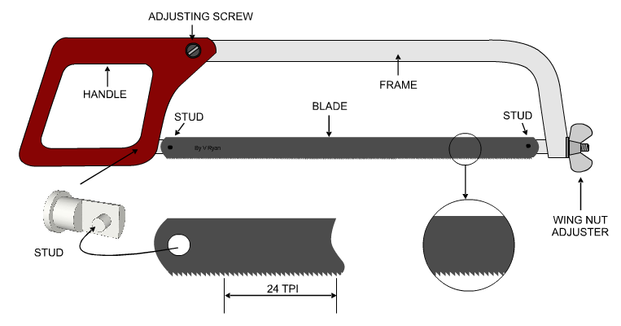
- The hack Saw

The hack Saw is mainly used to cut steels and metal material. But it can be
also used to cut plastic.

- The coping Saw
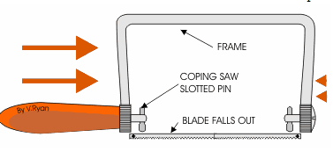
The coping saw is mainly used to
cut wood. It is also useful for cutting unique shapes and curves.

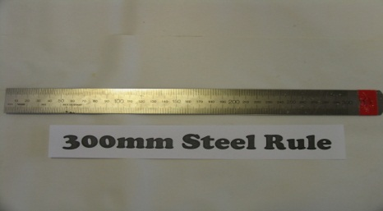
- Steel Rule

This is a steel rule. It is used to measure
lengths in design technology and you can do nothing without it.

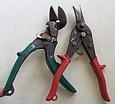
- Snips

The snips are usually used to cut metal and
other tough material.

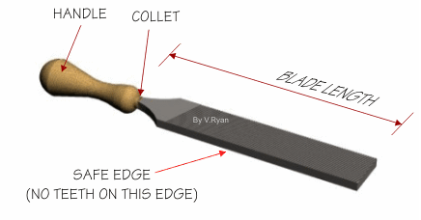
- File

The file is usually used to smooth edges. They can be used on a lot of different materials such as steel, wood etc.

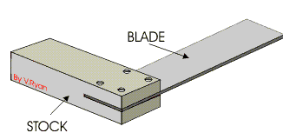
- Engineer Square

The engineer square is used for cutting and shaping the product that you are going to make.

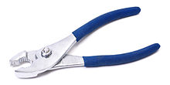
- Pliers

The plier is mainly used for bending or
physical compression.

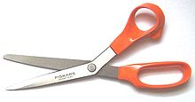

- Scissors

Scissors are used to cut thin materials
such as paper, cardboard and etc.

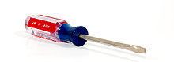
- The Screw driver

The screw driver is used to screw in
bolts. There are different types of
screw drivers for each bolt.

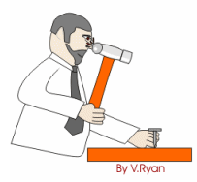
- Hammer
The hammer is used to put nails in to a
material.

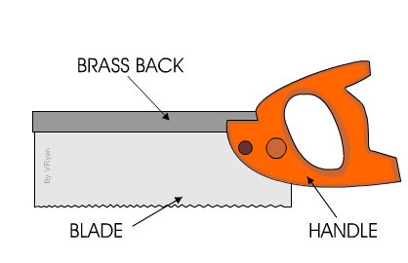
- Tenon saw

The tenon saw is generally used to cut moruse and tenon joints.

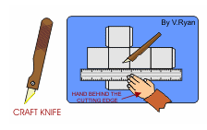
- Craft Knife

The craft knife is used to cut out
shapes. You also need a mat under
what you are cutting because it could
damage your table.

- What do you need to make for your product and where you plan to find it.

I plan to find everything I am going to use in the Design Technology Lab. I am going to use wood, metal, and waterproof material for the emergency shelter that I am going to make. I am also going to use some cloth and sewing material for the door of my emergency shelter.

- Photo’s / diagrams of websites on the internet + how useful they are

I never knew how to use a hammer but when I read about how to use a hammer carefully in technologystudent.com, I feel like I could actually use a hammer right now and make something. I also learned that you could hurt yourself while you are in the process of making things and you should be extra careful on what you touch for not just hammers, but for all the tools and materials that I am going to use to make my emergency shelter come alive.

Design Brief
I am going to make an emergency shelter for the floods that happen in the world. I am going to make an emergency shelter that could be unique in which people could see right away. This is designed for a flood should be able to be in high places. I am going to use waterproof material, wood, and metal to make my emergency shelter. This shelter is going to be for about 5-10 people per shelter, and it is going to save people from shivering to death after they have lost their homes.

Specification
Target Market: The target market for my emergency shelter is people in China who have lost their homes because of a flood.
Functions: The function that my product does is giving a person shelter and giving them warmth.
Materials: wood, waterproof material, cloth, and metal will be used to make my emergency shelter.
Ergonomics/ overall sizes: The size of the emergency shelter will be for about 5-10 people.
Manufacturing processes and quantity: When my product is manufacturing I will check again and again to see if it is not stable. I will make about, 1050 emergency shelters because there are a lot of people living in China.
Equipment/ tools- requirements: The tools that I will need are Hack Saw, Coping saw, Steal rule, Snips, File, Engineer square, Pliers, Scissors, Screw driver, Hammer, Tenon saw, and a Craft knife.
Maintenance Requirements: The emergency shelter shouldn’t be that crowded because it is a unique shape and could break if there is too much pressure on it.
Product life span and life cycle: The emergency shelter could be used again and again because this is a shelter and us reusable.
Aesthetic appearance (Shape, color, texture): The shape of this shelter is going to be a hexagonal prism. The color is going to be translucent because they need some privacy but also need a sense of what is going on outside.
Quality Assurance: Quality assurance will be held so that the people who use my emergency shelter knows how safe it is.
Quality Control: The quality control will be held once a month to check if the emergency shelter is stable or not.
Cost: The cost of this shelter is about 100 TL because if it is too expensive no one will buy it.
Time scale and planning: Roughly about 48 hours will be used to make and plan this emergency shelter.
Health and safety: To check that my emergency shelter is safe we will check its stability after it is made numerous times.

Works Cited
Meinhold, B. (2010, September 7). AirDrop House Emergency Shelter for Flood-Afflicted Areas. Retrieved September 22, 2012, from Inhabitat design will save the world: http://inhabitat.com/airdrop-house-emergency-shelter-for-flood-afflicted-areas/
N/A. (N/A, N/A N/A). Emergency Shelters. Retrieved September 22, 2012, from Shelters&bunkers: http://www.sheltersbunkers.com/emergency-shelters.htm
N/A. (N/A, N/A N/A). Screwdriver. Retrieved September 22, 2012, from Wikipedia: http://en.wikipedia.org/wiki/Screw_driver
N/A. (N/A, N/A N/A). Snips. Retrieved September 22, 2012, from Wikipedia: http://en.wikipedia.org/wiki/Snips
N/A. (N/A, N/A N/A). Pliers Retrieved September 22, 2012, from Wikipedia: http://en.wikipedia.org/wiki/Pliers
Steel Rule. (N/A, N/A N/A). Retrieved September 22, 2012, from Clounagh Technology: http://clounaghtechnology.wordpress.com/sequence-drawings/tools-for-wood/steel-rule/
Ryan, V. (N/A, N/A N/A). BACK SAWS - TENON SAWS AND DOVETAIL SAWS. Retrieved September 22, 2012, from technologystudent.com: http://www.technologystudent.com/equip1/bksaw1.htm
Ryan, V. (N/A, N/A N/A). BASIC DRAWING / OFFICE EQUIPMENT - 3. Retrieved September 22, 2012, from technologystudent.com: http://www.technologystudent.com/despro2/basdrw3.htm
Ryan, V. (N/A, N/A N/A). HAND FILES / ENGINEERS FILES - 1. Retrieved September 22, 2012, from technologystudent.com: http://technologystudent.com/equip1/hfile1.htm
Ryan, V. (N/A, N/A N/A). HOW ED the HANDYMAN USES A HAMMER. Retrieved September 22, 2012, from technologystudent.com: http://www.technologystudent.com/health1/ed13.htm
Ryan, V. (N/A, N/A N/A). THE COPING SAW. Retrieved September 22, 2012, from technologystudent.com: http://technologystudent.com/equip1/coping1.htm
Ryan, V. (N/A, N/A N/A). THE ENGINEERS TRY-SQUARE. Retrieved September 22, 2012, from technologystudent.com: http://www.technologystudent.com/equip1/try2.htm
Ryan, V. (N/A, N/A N/A). The Hacksaw. Retrieved September 22, 2012, from technologystudent.com: http://technologystudent.com/equip_flsh/hacksw1.html
Yoneda, Y. (2011, Feburary 26). Parasitic Emergency Homes Can Be Implanted Onto Abandoned Buildings. Retrieved September 22, 2012, from Inhabitat design will save the world: http://inhabitat.com/parasitic-emergency-homes-can-be-implanted-onto-abandoned-buildings/

